# Freshco Hypermarket Report

**Order Level Analysis**

1. Order Count by Location and Slot:

Insights:

1. Harlur, HSR Layout, ITI Layout and Bomannahali - MicoLayout consistently show high order counts, indicating strong demand.
2. Bellandur, Green Glen is a notable area with a significant order count, particularly in the evening and late-night slots.
3. Morning and Afternoon slots are popular across most areas, suggesting that customers prefer daytime deliveries.

Observations:

1. There is a considerable variation in order distribution among different areas and slots, highlighting the need for tailored strategies in different regions.
2. Late Night slot orders are generally lower compared to other slots, indicating a potential area for growth or targeted promotions.

2. Areas with Highest Increase in Monthly Orders

Insights:

1. Harlur and HSR Layout consistently show high monthly order increases, reflecting a growing customer demand in these areas.

2. ITI Layout, Kudlu also exhibit significant increases in monthly orders over the analyzed period.

Observations:

1. Identifying areas with substantial order growth helps in focusing marketing efforts and operational strategies to meet increasing demand.
2. Understanding the reasons behind fluctuations in different areas can guide targeted interventions.

Graph :-Distribution Of Order Across Various Areas

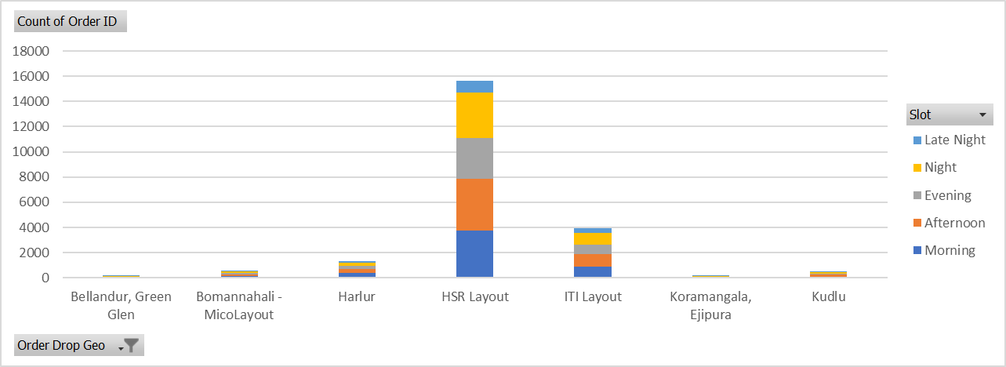

1. Month Vs Count Of Order

Insights and Observations:

Seasonal Variation:

1. There is a noticeable increase in the number of orders from January to September, with September having the highest count.
2. The trend suggests a potential increase in demand over time, possibly influenced by factors such as promotions, events, or seasonal changes.

Monthly Growth:

1. The growth from January to September is substantial, indicating positive momentum and a growing customer base.
2. A consistent increase in order count month over month may signify effective marketing strategies or improved service offerings.

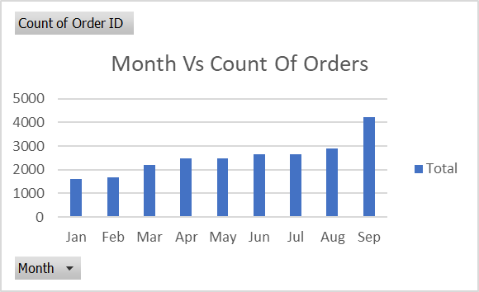

1. Delivery Charges as a Percentage of Product Amount

Insights:

1. Late Night deliveries tend to have higher delivery charges as a percentage of the product amount.
2. Delivery charges as a percentage are generally higher in the Evening and Night slots, indicating potential areas for optimization.

Observations:

1. Assessing the impact of delivery charges on different slots and months can guide pricing strategies for better customer satisfaction.

Graph:- Delivery Charges At Different Slots

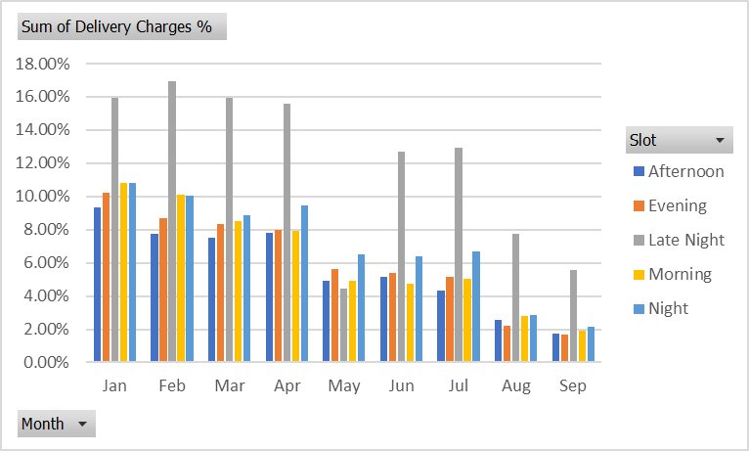

1. Discount as a Percentage of Product Amount At Slot And Month

Insights:

1. August has the highest discount as a percentage of the product amount, suggesting potential promotional activities during this month.
2. Morning and Late Night slots consistently show lower discounts compared to other slots.

Observations:

1. Analysing discount trends helps in understanding customer behaviour and can inform pricing and promotion strategies.

Graph:- Discount At Different Slots

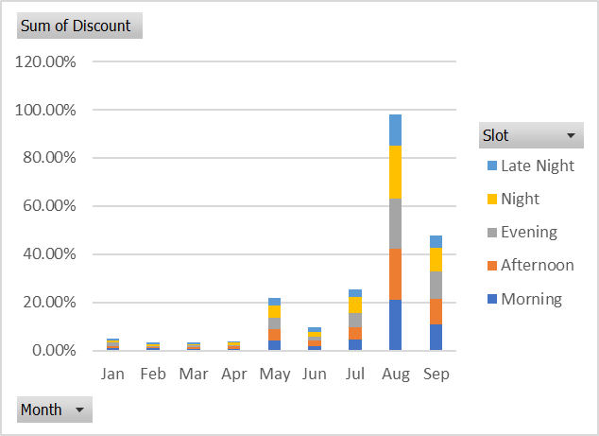

1. Discount as a Percentage of Product Amount at Drop Area

Insights:

1. Bilekahalli and Harlur exhibit higher discount percentages across all slots, indicating similar strategy to be applied on other areas to acquire more customers.

Observations:

1. Identifying areas with higher discount percentages can guide targeted promotional activities to optimize marketing budgets.

Additional Recommendations:

1. Customer Feedback:

* Collect and analyse customer feedback to identify areas for improvement.
* Use feedback to enhance customer satisfaction and loyalty.

1. Competitive Analysis:

* Conduct a competitive analysis to understand pricing and promotions in the market.
* Adjust strategies to stay competitive while maintaining profitability.

1. Operational Efficiency:

* Optimize operational processes to meet varying demand patterns efficiently.
* Ensure timely deliveries and enhance overall customer experience.

1. Promotional Campaigns:

* Launch targeted promotional campaigns based on identified trends and opportunities.
* Collaborate with local businesses for cross-promotions to attract a wider audience.

**Completion Rate Analysis**

1. Completion Rate at Slot vs. Day of the Week Level

Insights:

1. Sunday has the highest completion rate, followed closely by Saturday and Friday, indicating that weekends generally have higher order completion rates.
2. Late Night slots consistently show a lower completion rate compared to other slots across all days of the week.

Observations:

1. Consider optimizing resources and logistics for Late Night slots to improve completion rates.
2. Weekends are crucial for customer satisfaction, so ensuring efficient operations on Saturdays and Sundays is essential.

Graph:- Completion Rate VS Days of the week

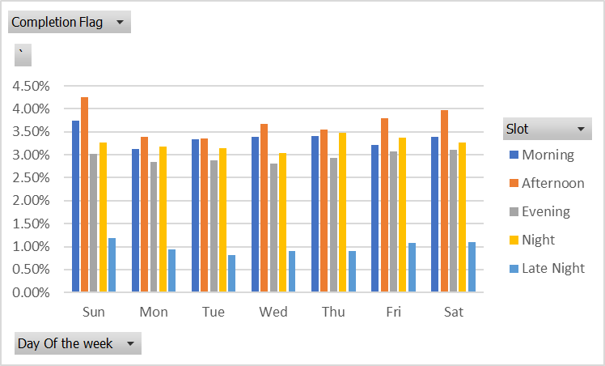

2.Completion Rate at Drop Area Level

Insights:

1. HSR Layout has the highest number of completed orders, followed by Harlur and ITI Layout, indicating these areas have higher order fulfilment.
2. Koramangala Ejipura, Bellandur Green Glen has a completion rate close to 100%, suggesting efficient order processing in this area.

Observations:

1. Identify reasons behind lower completion rates in certain areas to improve service quality and customer satisfaction.
2. Focus on maintaining or improving the high completion rates in areas like HSR Layout , Bellandur, Green Glen and Koramangala Ejipura.

Graph :- Completion Rate At Drop Area

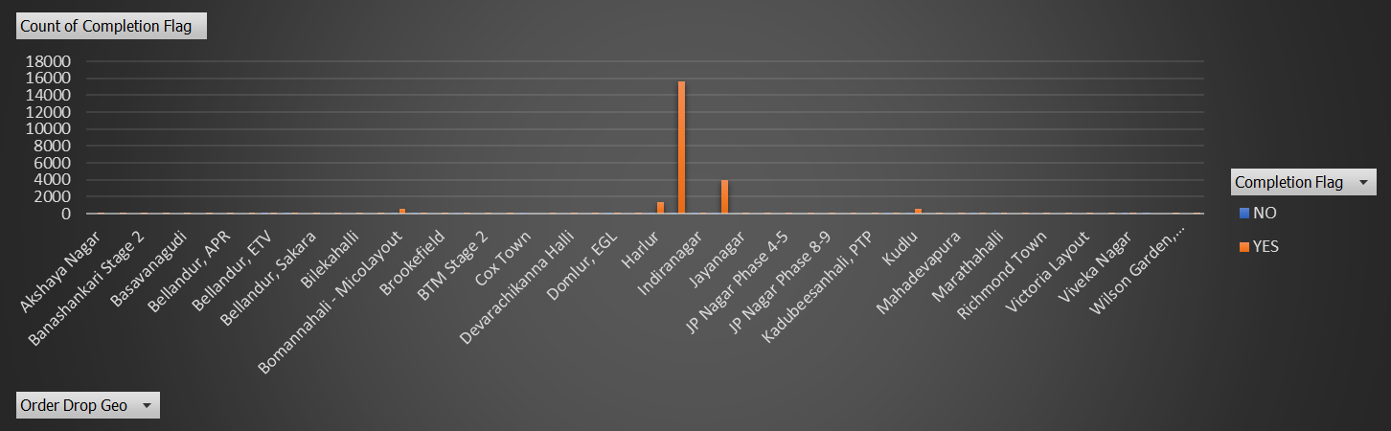

1. Completion Rate at Number of Products Ordered Level

Insights:

1. The completion rate of orders in 99.64 % that means almost all the orders which are placed are completed only 0.36% have not been delivered.

Observations:

1. Efficiently handling larger orders is crucial for maintaining a high completion rate.
2. Investigate the reasons behind the lower completion rate for orders with no products, as it might indicate a data anomaly or a specific type of order.

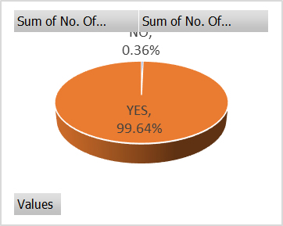

Observations and Recommendations:

1. **Slot Optimization**: Consider evaluating and potentially adjusting resources during Late Night slots to improve completion rates.
2. **Area-Specific Strategies**: Focus on addressing challenges in areas with lower completion rates to enhance overall service quality.
3. **Order Size Impact**: Recognize the importance of efficiently handling larger orders for better customer satisfaction.
4. **Data Anomalies**: Investigate and validate the data for areas with unusual completion rates to ensure accurate insights.

**Customer Level Analysis**

1. Completion Rate at Source Level

Insights:

1. Organic and Google sources have the highest completion rates, indicating these sources contribute to successful orders.
2. Facebook, Instagram, and Snapchat show lower completion rates compared to other sources.

Observations:

1. Investigate and address potential issues affecting completion rates for sources like Facebook, Instagram, and Snapchat.
2. Allocate resources effectively to capitalize on high-performing sources like Organic and Google.

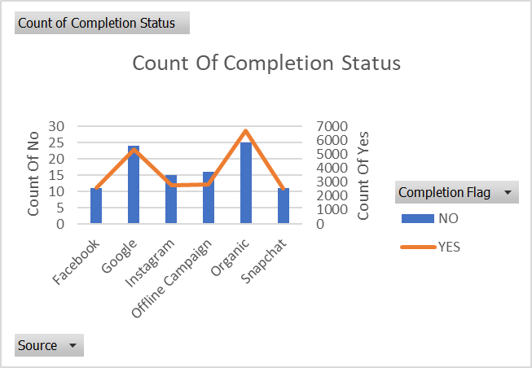

2. Average Revenue per Order at Acquisition Month Level

Insights:

1. Average revenue per order shows fluctuation across months, with a peak in May.
2. September has the lowest average revenue per order.

Observations:

Investigate the factors contributing to the peak in May and explore strategies to improve revenue in lower-performing months.

1. Aggregated LTV at Acquisition Month Level

Insights:

1. LTV increases steadily from January to September, indicating potential improvements in customer retention or acquisition strategies over time.

Observations:

1. Explore factors contributing to the increasing LTV trend, such as marketing initiatives, product offerings, or customer engagement strategies.

Graph: LTV vs Acquisition Month

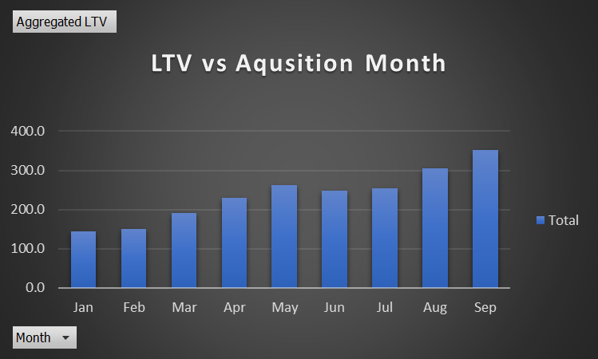

1. Analysis of Aggregated LTV at Customer Acquisition Source
2. Google Dominates Aggregated LTV:

Insight:

- Google has the highest aggregated LTV among customer acquisition sources.

Observation:

- Customers acquired through Google contribute significantly to the overall revenue.

2. Diversity in LTV Across Sources:

Insight:

- There is a range of aggregated LTV values across different sources.

Observation:

- The diverse LTV values highlight the varying customer behaviours and revenue contributions from different acquisition sources.

3. Facebook and Snapchat Lagging in Aggregated LTV:

Insight:

- Facebook and Snapchat show lower aggregated LTV values.

Observation:

- There might be opportunities to enhance customer engagement and spending for these sources.

4. Organic Source Performance:

Insight:

- Organic source has a relatively high aggregated LTV.

Observation:

- Customers acquired organically have a significant long-term value for the business.

Graph:- Aggregate LTV vs Count of User id

**Delivery Analysis**

1. Average overall delivery time at month and delivery area level.

Insights and Observations:

1. Average Delivery Time:

**Overall Trend**: Delivery times vary across different locations.

Fastest Delivery: Whitefield and Cox Town have remarkably short average delivery times.

**Challenges**: Mahadevapura and Richmond Town show exceptionally long delivery times, possibly indicating operational challenges.

2. Slot-Specific Analysis:

**Morning Slots**: Generally have shorter delivery times, indicating efficient morning operations.

**Late-Night Slots**: Delivery times are inconsistent, with some areas experiencing longer times, suggesting potential operational issues during late hours.

Graph:- Average Delivery Time At Slot Level

3. Geographic Variation:

**Central Areas:** Locations like Wilson Garden, Shantinagar, and Indiranagar exhibit varying delivery times, potentially influenced by geographic factors or order density.

**Suburban Areas**: Residential areas like HSR Layout and Bellandur show balanced delivery times.

4. Monthly Trends:

**May:** Shows a spike in delivery times across multiple locations, indicating a potential external factor affecting overall delivery efficiency.

1. Overall delivery time at month and weekday/weekend level.

Insights and Observations:

1. Overall Trend:

**Weekday vs. Weekend:** On average, delivery times are slightly longer during the weekend compared to weekdays.

**Monthly Averages:** The overall trend shows variations in delivery times across different months.

2. Monthly Analysis:

**May Spike:** May exhibits a significant increase in delivery times, indicating potential challenges or increased demand during that month.

**February Efficiency:** February shows the most consistent and efficient delivery times.

3. Weekday/Weekend Comparison:

**Weekday Consistency:** Delivery times are more consistent on weekdays, suggesting smoother operational processes during these days.

**Weekend Fluctuations**: Longer delivery times on weekends may be attributed to increased order volume or different customer behaviour.

4. Operational Considerations:

**May Challenges:** Address the challenges observed in May to ensure consistent and efficient delivery operations.

**Weekend Optimization:** Evaluate and optimize weekend delivery operations to bring them in line with weekday efficiency.

Graph:- Average Delivery Time vs Weekday/Weekend At Month Level

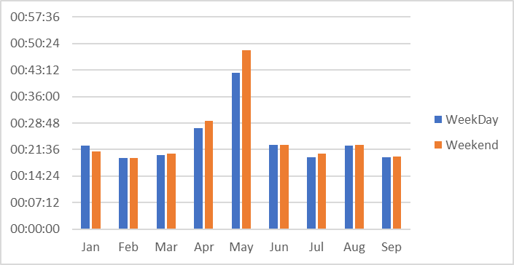

1. Delivery charges with slot and delivery area

**Time Slot-Based Pricing:**

1. The table shows delivery charges across different time slots (Morning, Afternoon, Evening, Night, Late Night) for various areas.
2. Late Night deliveries have the highest average delivery charge (32.29), while Morning deliveries have the lowest (19.00).

**Area-Specific Pricing:**

1. Delivery charges vary across different areas, indicating a tailored pricing strategy based on location.
2. For instance, Brookefield has the highest charges across all time slots, suggesting potential factors such as distance, demand, or operational costs in that area.

**Cost Considerations:**

1. Areas like Bellandur, Ecospace, and Bellandur, ETV, have minimal or zero charges for some time slots. Understanding the reasons behind these variations can provide insights into the pricing strategy and cost considerations

**Differential Pricing:**

1. Some areas, such as Arekere and Banashankari Stage 2, have consistent charges across all time slots, while others, like Bellandur, Sakara, show variations. This indicates a potential strategy of differential pricing based on demand patterns or operational considerations.

Graph:- Areas With Highest Delivery Charges